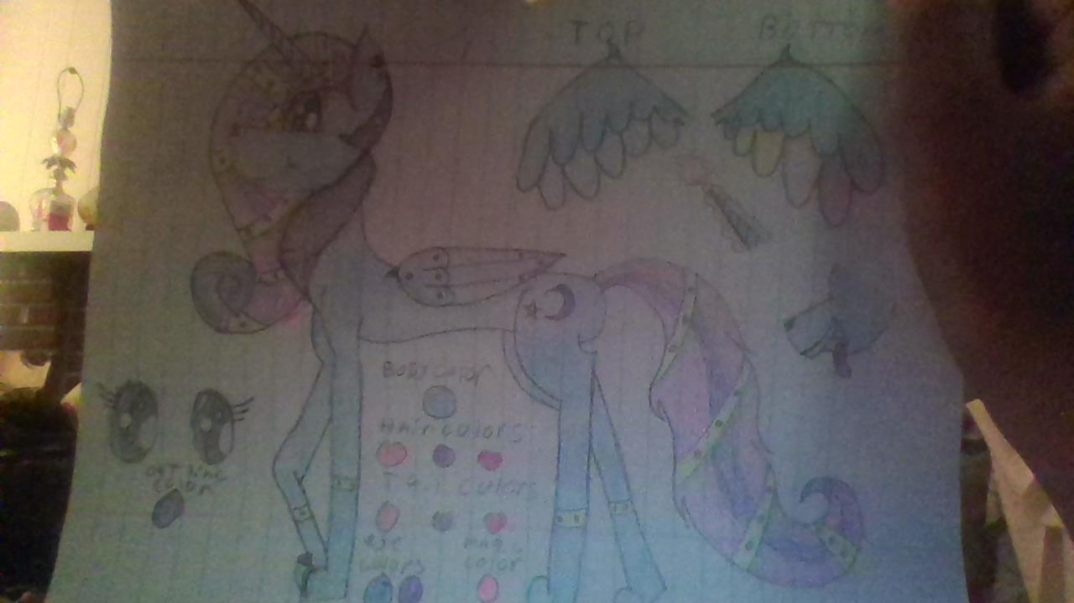

Princess Moonightwolfpup
Bio
Name: Princess Moonlightwolfpup
Nickname: Moonbeam or Moon
Age: 71 Years old
True Age: 170 Moons old
Birthdate: January 25th
Species: Winged-Alicorn Moonwolf, also half whickerbeast
Gender: Female
Sexual Orientaion: Bisexual(alittle omni as well)
Relashionship Role: Submission
Relationship: Mated
Language: Common, Flashes, Howls
Alighment: Neutral-psycic

Blood type: Galexy touch
Blood Color:Dark purple

Class(RP Role):warrior princess

Eastern Moon: Wolf
Western Moon: Dog

Food desire:Omnivore (eats most of everything)

Abilities
Sonic Moonbeam; can send a shocking beam of magic
Moon blast: a ball of stored magic into a blast
Moon Shock: the alility to send a shock through the body
Sonic Rainboom: a gient rainbow from flying fast from a high distance

Apperance
Hight:8’6” at sholders 6’8” at head
Length: 30’ from snout to tail 10’ is the length of my tail out of the 30’
Common Hight: 3’6 at sholders 5’8” at head
Common Length:45’ from snout to head 15’is the length of my tail out of the 45’
Weight:197 lbs

Body: slim and flexable shape and smooth fur and fluffy at base of tail, is a light blue color fur and pink, purple and ruby tail colors, hair colors are pink, purple and ruby as well, on top of wings is dark blue and light blue, the under wings is dark blue and multicolored fethers, on fold of wings has a purple claw. whickerbeast ruffle of hair from back of head to front of chest its color is purple. Cutie mark is a moon with a star. Has purple gems on ends of wilgs.

Eye color:purple and blue
Body color:blue
Hair colors:pink, purple and ruby
Tail colors: pink, purple and ruby
Fether colors: blue and multicolored
‘Internal’ color: light purple
Other colors:yellow and dark purple

General Apperance

Head:
-head is a mix of whickerbeast and wolf
-has one set of ears but hearing can go far and wide
-one horn in middle of head that carrys magic
Body:
-body is a mix of whickerbeast and wolf as well
-Fluff of fur goes from back of head to front of chest, purple colored
-under belly is fluffy fur with little hints of purple
-end of tail is curled and fluffy

Front and back legs:
-front legs are clawed and alittle fluff at start
-Back legs are normal paws of a wolf
-Back legs are fluffed at bend of them and little purple hints
-front legs have smooth fur from paws and on up it gets fluffy

Tail:
-is curled at end and fluffed at tip
-is fluffy at base of tail with hints of purple

Other:
-inside maw is purple and tongue is ruby color
-under tail is purple

Mesurements
Claws(truesize):8” in length
Claws(common size): 5” in length
Tail(truesize):43’ in length
Tail(common size):34’ in length
Horn(true size):24” in length
Horn(common size):22”in length
Tongue(true size):39” in length
Tougue(common size):29” in length
Wings(true size): 15’ in length
Wings(common size):19’ in length

Sexual features
Crotch type:is a canine type
Crotch dimention:8”in weith and 5”in hight
Croth color: is a light ruby red

Colors
Purple
Pink
Ruby
Light blue
Dark blue
Red
Light pink
Dark purple

Art
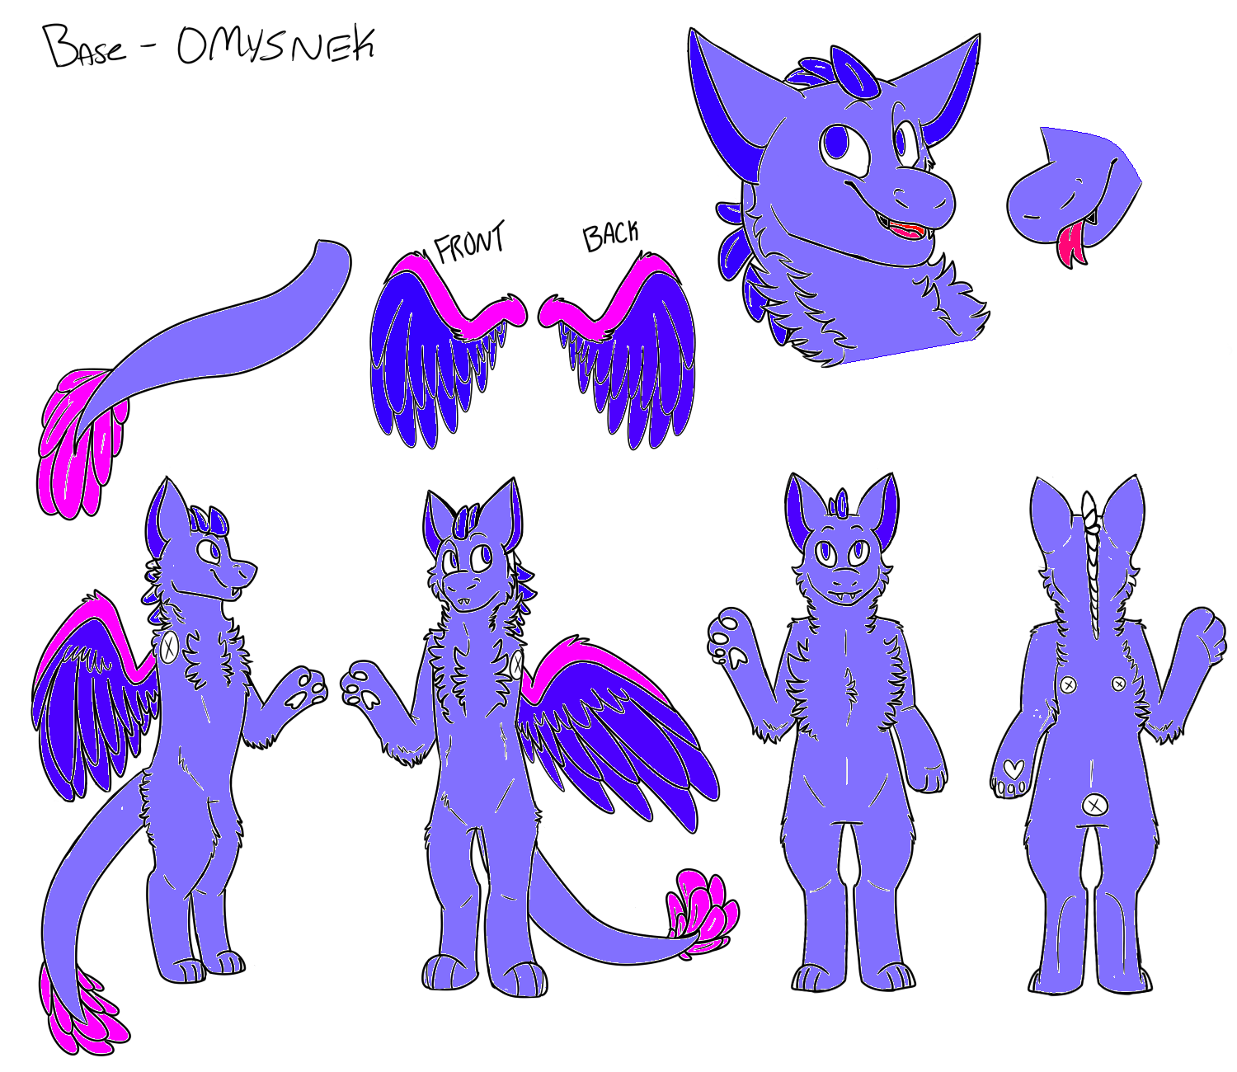
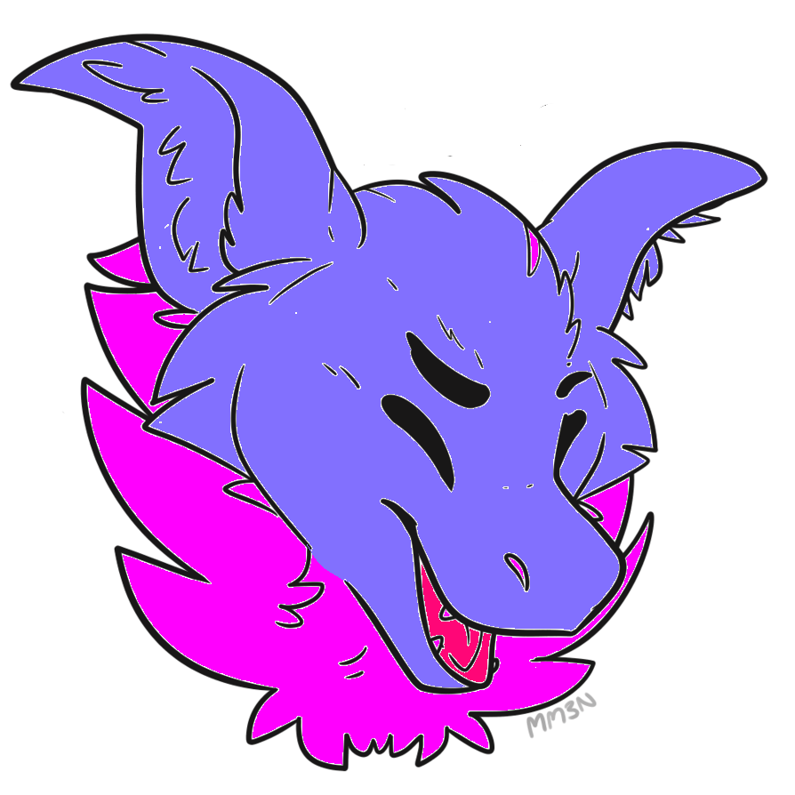
This art doesnt belong to me i used bases that i had found to refrence my fursona

